Git Labs الاسم: زيد محمد سعد الخثلان



My computer is operating system is MAC OS .

**Git-Lab1**

T1: open Terminal.

T2: Go to Desktopw with terminal.

cd Desktop

T3: create directory “git-test” in the desktop folder.

mkdir git-test

T4: Go to git-test and create a directory “test01” .

cd git-test

mkdir test01

T5: go to test01.

cd test01

T6: create repository by use git init.

git init

T7: create file “first.txt” and save it in the repository.

touch first.txt

git add .

git commit -m "create file"

T8: after the commit ,make file “second.txt” and save it in the repository.

touch second.txt

git add .

git commit -m "create file"

T9: after the commit ,make two file “third.txt” “fourth.txt” .

touch third.txt

touch fourth.txt

T10: save it in the repository ,and use the (add )and (commit) commands.

git add .

git commit -m "create two file"

T11: know show all the commits use git log command.

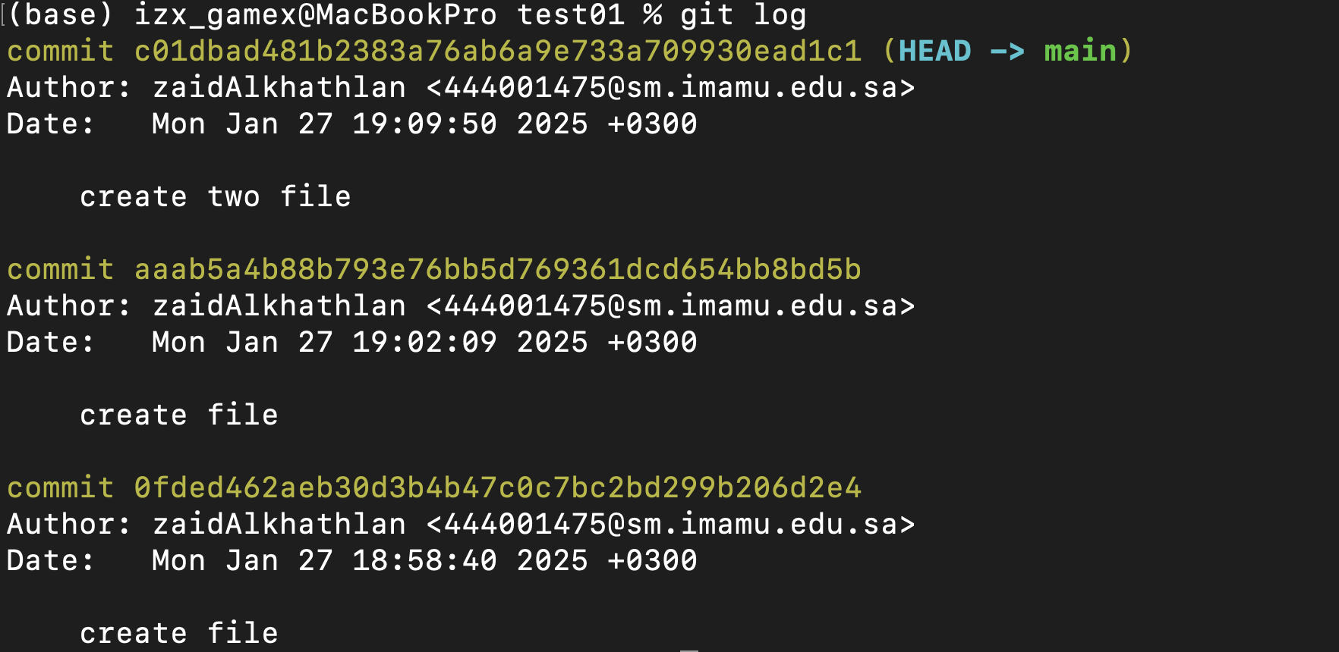

**Git-Lab2**

T1: open the terminal and go to test01 directory.

cd Desktop

cd git-test

cd test01

T2: show all the branches in the project.

git branch

T3:know create a new branch “new-feature” and switch to it.

git branch new-feature

git checkout new-feature

T4:in the new-feature branch create a file “lab02.txt” and add it and commit for this file.

touch lap02.txt

git add .

git commit -m "create new file in new-feature branch"

T5:show the files in new-feature branch.

ls

first.txt fourth.txt lap02.txt second.txt third.txt

T6: go back to main branch and show the files ,the file lap02.txt will be not there ,so merge the two branches .

ls

first.txt fourth.txt second.txt third.txt

git merge new-feature

T7:show the files in the main branch.

ls

first.txt fourth.txt lap02.txt second.txt third.txt

**Git-Lab3**

T1:go to the test01 directory.

cd Desktop

cd git-test

cd test01

T2:show the remote that is in it.

git remote -v

T3:go to GitHub and create a repository and copy the URL for the repository.

The URL: <https://github.com/zaidAlkhathlan/Git-lap.git>

T4:add the URL in the terminal.

git remote add origin https://github.com/zaidAlkhathlan/Git-lap.git

T5:upload all the files and edits to the repository use git push.

git branch -M main

git push -u origin main